Electric Circuits & Electronics Design Lab

EE 316-01

# Lab 3: Op-Amp Integrator and Differentiator Circuits

By: Jaiden Gann

Lab Section 316-01

Lab Date: 6/15/22

Lab Due: 6/22/22

## Introduction:

The purpose of this lab is to examine the characteristics of an op-amp integrator and Differentiator . We will be looking at how the outputs change for both op-amps depending on the type of wave given to it at input. This report will have 5 main sections. First is the theoretical analysis which is done as the pre-lab and includes Multisim simulations and handwritten solutions to the circuit; however, for this lab the handwritten work was optional. Then we have the physical circuits which are constructed on breadboards in lab. Afterwards, we compare the results from those 3 sections and conclude with an analysis of the results.

## Theoretical Analysis:

To begin, we considered an integrator which simply has the resistor that was in the negative feedback loop replaced with a capacitor. The configuration is shown in Figure 1. The output appears as an integration of the output. The integrator turns square waves into triangle and triangle waves into sine waves.

Next, we considered a differentiator which has the resistor at input replaced with a capacitor instead. The configuration is shown in Figure 2. The differentiator behaves opposite to the integrator.

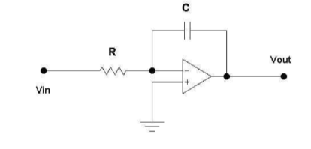

**Figure 1**. Integrator

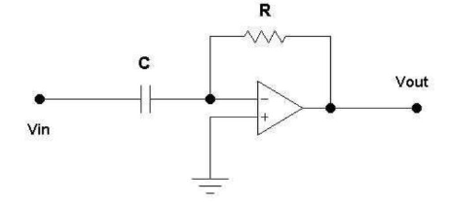

**Figure 2.** Differentiator

## Simulations:

For the next phase of the lab, we built and analyzed the op-amps in Multisim. We started with the integrator as shown with Figure 1 and then did a differentiator. The circuits created in Multisim can be seen in Figure 3 and 4. We looked at the outputs for triangle, square, and sine waves along with whether it was a 0.1µF or 1µF capacitor. As a note, during prelab correct wave output forms could not be gathered.

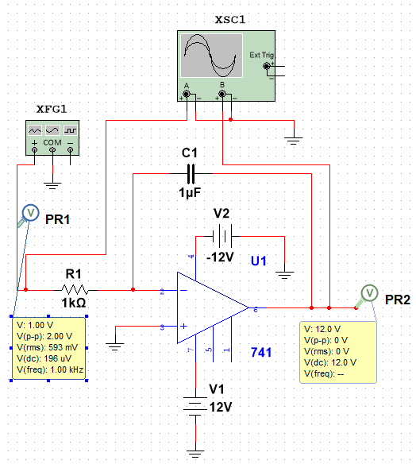

**Figure 3**: Integrator

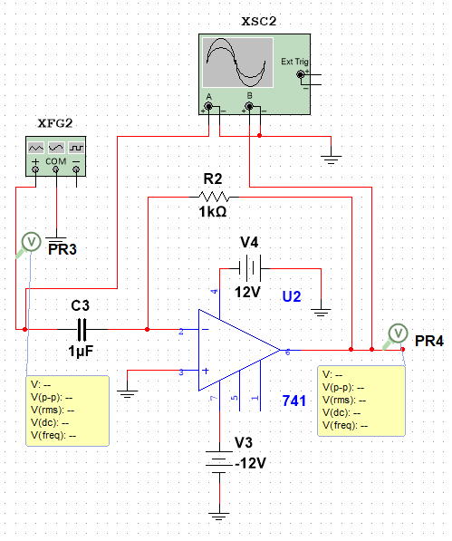

**Figure 4.** Noninverting Amplifier

## Experimental:

For the last portion of the lab, we did the same things as prior but on a physical board to validate the output results we obtained and/or expected. We started with the integrator from Figure 1 using a 741op-amp and referring to its pinout sheet. The oscilloscope probes were placed on the same wire or clip as the function generator which was used to generate our AC signal for one channel and the other channel was used to measure the output with that probe placed on a wire coming from pin 6 on the board. A 1µF capacitor was also added at the end of the output to filter out any noise.

The same thing was done for the differentiator from Figure 2, switching where the capacitor and resistor were. The probes stayed where they were as we simply moved the capacitor and resistor. The results for the integrator can be seen in Figures 5 through 10 in and the differentiator is Figures 11 through 16 . The constructed circuits can be seen in Appendix 2.

## Results and Discussion:

The wave outputs match pretty close with what we expected given what an integrator and differentiator should do based on the input wave provided to it. While the output matched a few times the oscilloscope was giving very high voltage values. I tried switching to a different station but then the wave outputs were not correct and had a lot of noise in them. The extra capacitor was added to try and filter out some noise and for some circuits it lowered the voltage and gave the correct output but for others the output wasn’t showing as expected. It is unclear what was going on, the circuit seemed to be built correctly and nothing seemed wrong with the board and equipment, so I am not sure why the high voltage output occasionally or why only sometimes the extra capacitor seemed to work. Two examples of this are Figure 5.1 and 14.1, where I had gone back with the extra capacitor added the output and it seemed to lower the output voltage coming out.

There did not seem to be any clipped outputs. Each scenario came back with an output wave as expected. However, clipping is when the output voltage starts to exceed the supply voltage.

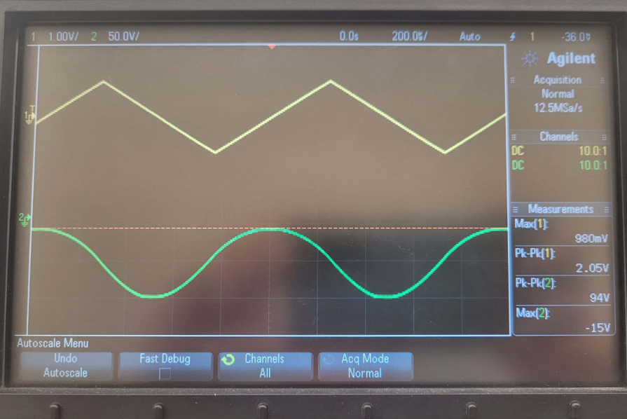

**Figure 5.** Integrator with 0.1µ Capacitor and Triangle Wave

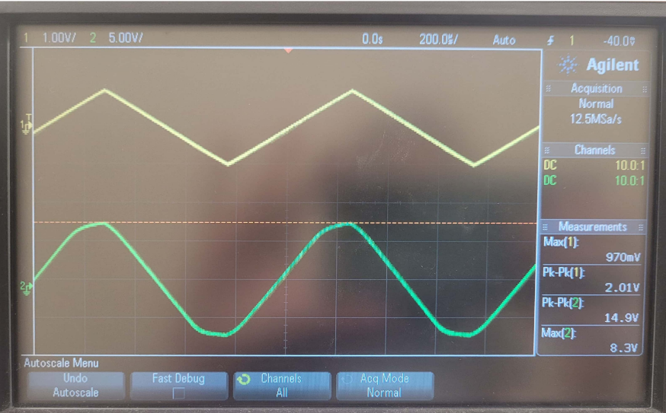

**Figure 5.1.** Integrator with Triangle wave and 0.1µ, Low Voltage

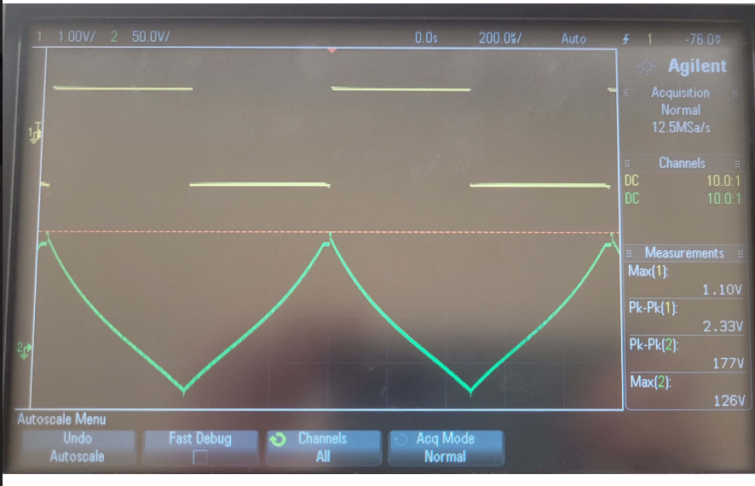

**Figure 6.** Integrator with Square wave and 0.1µ

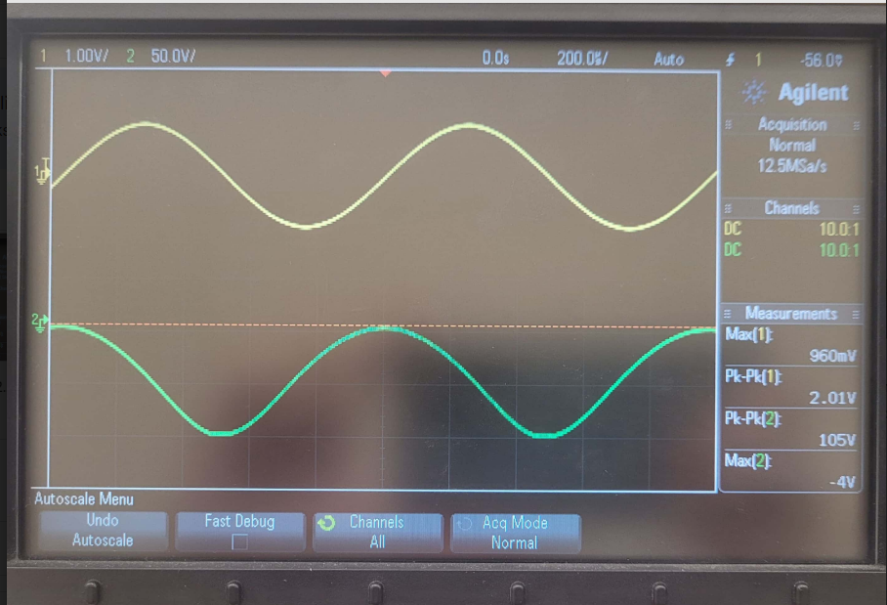

**Figure 7.** Integrator with Sine wave and 0.1µ

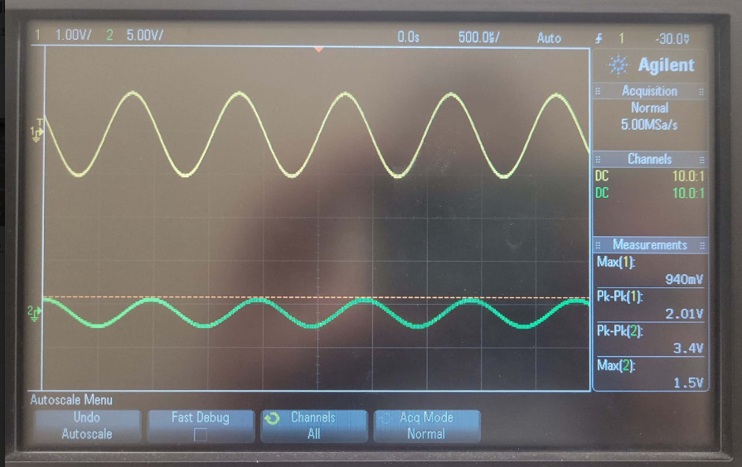

**Figure 8.** Integrator with Sine wave and 1µ

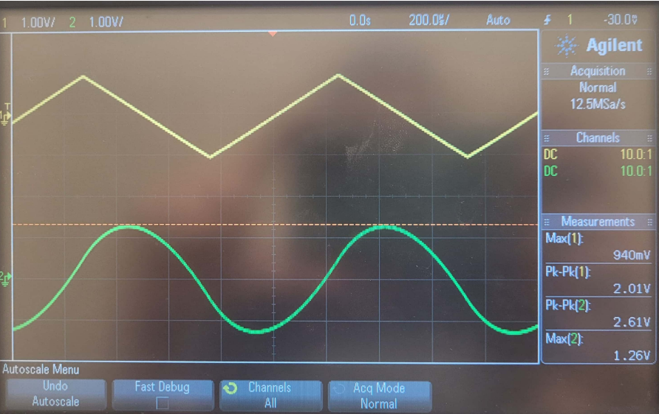

**Figure 9.** Integrator with Triangle wave and 1µ

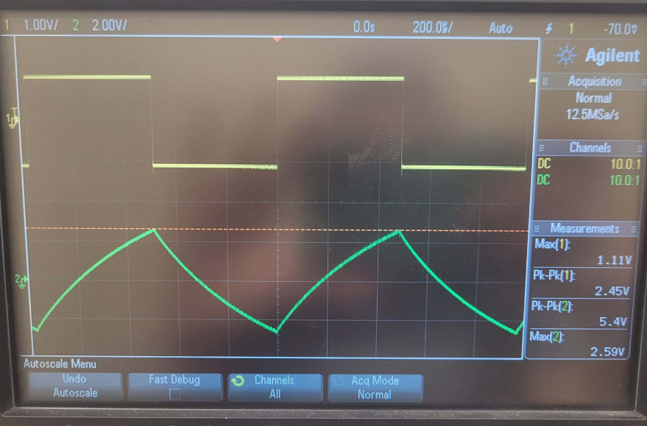

**Figure 10.** Integrator with Square wave and 1µ

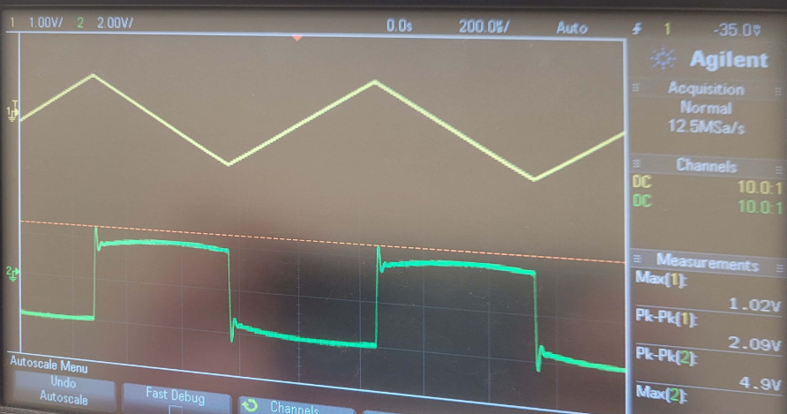

**Figure 11.** Differentiator with Triangle wave and 0.1µ

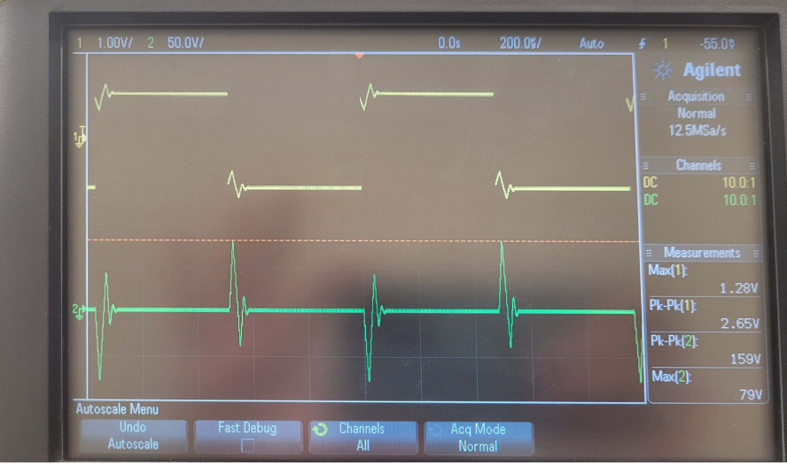

**Figure 12.** Differentiator with Square wave and 0.1µ

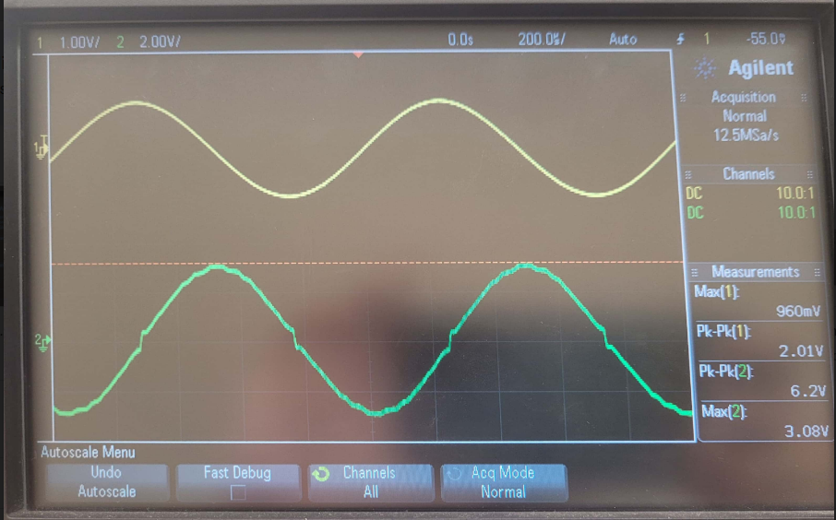

**Figure 13.** Differentiator with Sine wave and 0.1µ

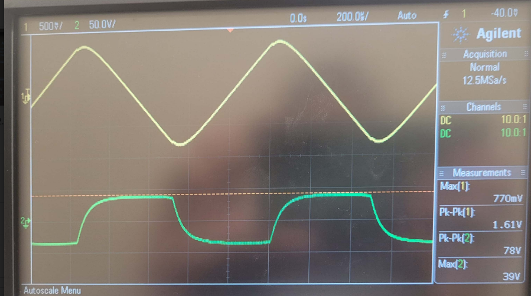

**Figure 14.** Differentiator with Triangle wave and 1µ

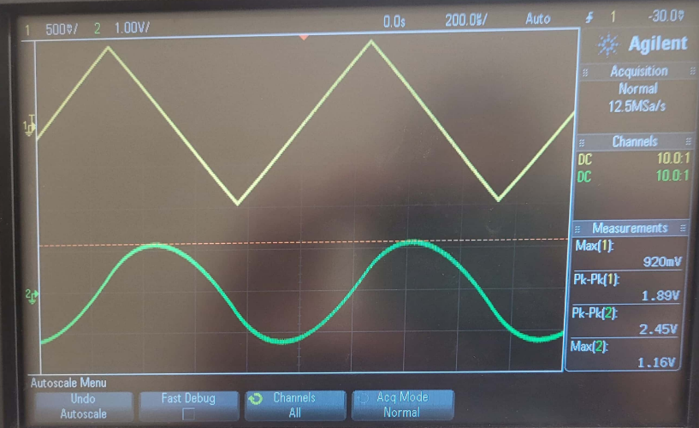

**Figure 14.1.** Differentiator with Triangle wave and 1µ, Low Voltage

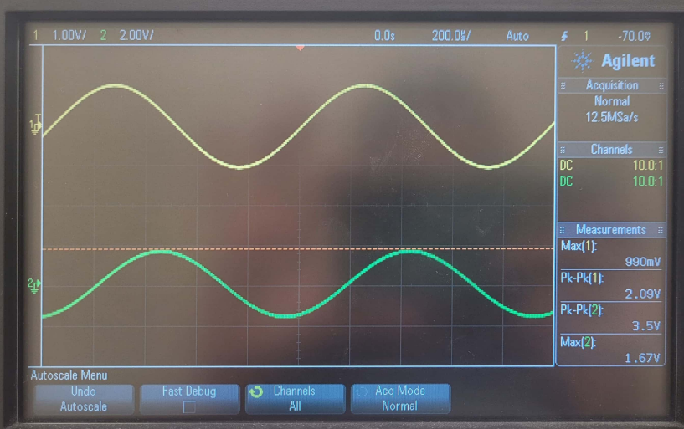

**Figure 15.** Differentiator with Sine wave and 1µ

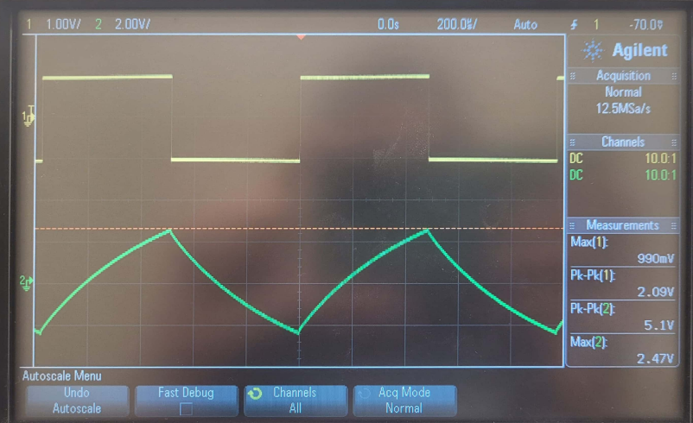

**Figure 16.** Differentiator with Square wave and 1µ

## Conclusion

Overall, the results of the lab were line with our expectations based on what we said an integrator and differentiator should do in the theoretical portion. Good data from the simulation side could not be obtained so a true comparison couldn’t be done. The results of this lab showed us the expected wave output we should get from an integrator and differentiator. All together the lab furthered our knowledge of circuits and working with the lab equipment.

## Appendix 1:

N/A- did not attempt

## Appendix 2:

Signed lab results

N/A

Pictures of Circuits

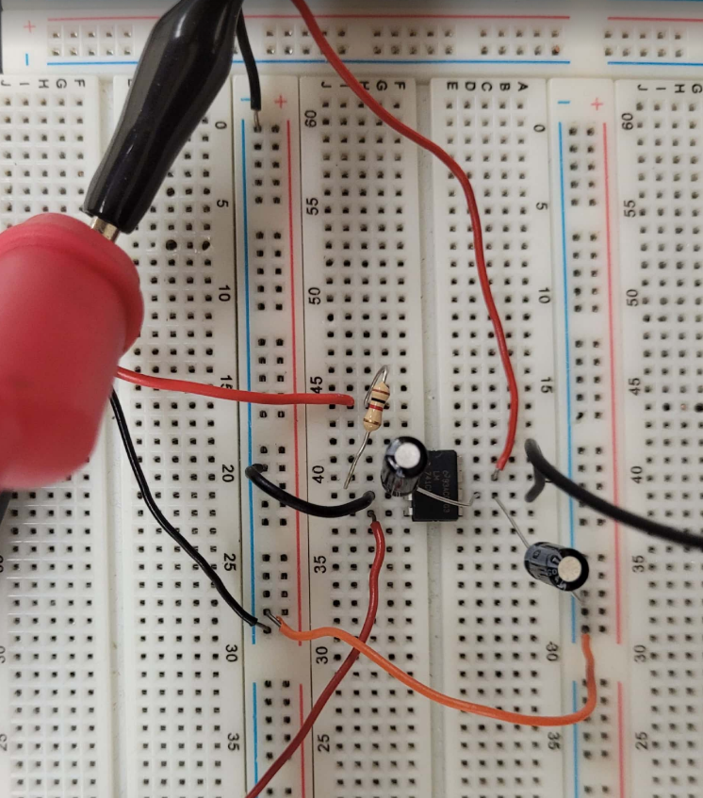

Figure 1 (Integrator) physical circuit

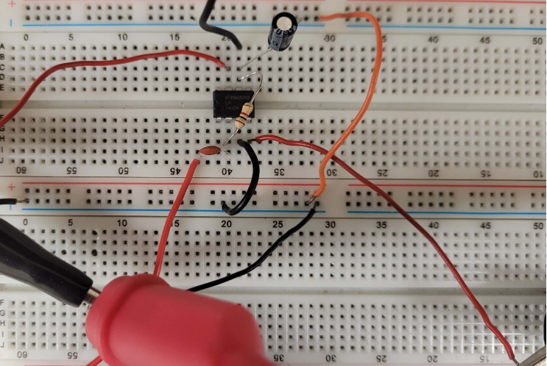

Figure 2 (Differentiator) physical circuit